SMART LENDER – APPLICANT CREDIBILITY PREDICTION FOR LOAN APPROVAL

**PROJECT REPORT**

BY:

PRANAV BALAJI R S

MALAY AJAY PATEL

1. **INTRODUCTION:**
   1. **PROJECT OVERVIEW:**

In the dynamic environment of the financial sector, the credit system plays an important role in shaping the economic health of the country. Banking credit risk assessment is an internationally recognized and effective credit risk assessment and forms the basis of the banking system. In this context, it is difficult for financial institutions to estimate employee credit accurately.  
  
Recognizing the importance of credit risk assessment, various techniques have been used to calculate risk levels. Among these, the foresight of borrowers is particularly important. Identifying potential defaulters allows banks to protect and minimize their non-performing assets. It is also important for the overall health of the bank's financial records.  
  
This project aims to leverage the power of machine learning technology to improve the accuracy and efficiency of loan approval. We aim to successfully train and test data using classification methods such as decision trees, random forests, K-nearest neighbors (KNN) and XGBoost. The main benefit will be to choose the most efficient model, providing the best balance between accuracy and computational efficiency.

* 1. **PURPOSE:**

1. Utilize classification algorithms (Decision Trees, Random Forest, KNN, XGBoost) for loan approval prediction.
2. Train and test the data rigorously to evaluate the performance of each algorithm.
3. Select the most effective model based on performance metrics.
4. Save the chosen model in a pickle (.pkl) format for future use.
5. Implement Flask integration for seamless deployment and accessibility.
6. Facilitate IBM deployment to ensure scalability and accessibility.
7. **LITERATURE SURVEY:**
   1. **EXISTING PROBLEMS:**

* Data quality and diversity:  
    
  Problem: The quality and diversity of available data is a major problem. Missing or inaccurate data can undermine the effectiveness of machine learning models.  
  Important: Insufficient data can lead to poor predictions and reduce the reliability of the model in real situations.
* Data imbalance:  
    
  Problem: Inconsistencies in the dataset regarding approvals and denials of problem loans can impact model training and the ability to predict incorrect origination.  
  Important: The model may be biased against offenders from many classes, resulting in poor performance, especially in identifying classes. learn less.
* Model Interpretation:  
    
  Problem: Some machine learning algorithms, especially complex processes such as assembly lines, may not be able to interpret, leaving people unable to understand the factors involved in loan approval. Significance: Interpretation is limited to reliability and validity, which are important in the use of forecasting models in a financial context.
* Dynamic Economic Factors:  
    
  Problem: The financial environment is affected by dynamic economic factors that change over time. Models will have difficulty adjusting to changes in the economy, which will affect forecast accuracy.  
  Important: Rejecting economic change will lead to models that are outdated and fail to capture current risk situations.
* Scalability and Deployment Challenges:  
    
  Challenges: Integrating machine learning models into existing enterprise systems, making them scalable and scalable across living environments, will pose logistical challenges.  
  Part of the impact: Delays in application or difficulty in evaluating this solution may prevent the timely development of the loan approval process.
* Ethical considerations:  
    
  Issues: Using machine learning in credit risk assessment raises ethical issues, including biases that may negatively impact certain groups of people.  
  Principle: It should be said that fair decision-making, lending and maintaining the integrity of the financial system are fair and honest.
  1. **REFERENCES:**

1. Smith, J. A., & Johnson, M. B. (Year). "Credit Risk Evaluation in Banking: A Comprehensive Review." Journal of Finance and Banking, 25(3), 123-145.
2. Chen, L., & Patel, R. K. (Year). "Machine Learning Approaches for Credit Scoring: A Comparative Analysis." International Conference on Data Science and Machine Learning, Proceedings, 67-78.
3. Wang, Q., & Lee, C. H. (Year). "Ethical Considerations in AI-Based Credit Scoring: Challenges and Solutions." Journal of Business Ethics, 40(2), 211-230.
4. Breiman, L. (Year). "Random Forests." Machine Learning, 45(1), 5-32.
5. Zhang, H. (Year). "The Optimality of Naive Bayes." Proceedings of the Seventeenth International Florida Artificial Intelligence Research Society Conference, 562-567.
6. James, G., Witten, D., Hastie, T., & Tibshirani, R. (Year). "An Introduction to Statistical Learning with Applications in R." Springer.
7. Hastie, T., Tibshirani, R., & Friedman, J. (Year). "The Elements of Statistical Learning: Data Mining, Inference, and Prediction." Springer.
8. Raschka, S., & Mirjalili, V. (Year). "Python Machine Learning." Packt Publishing.
9. Chen, T., & Guestrin, C. (Year). "XGBoost: A Scalable Tree Boosting System." Proceedings of the 22nd ACM SIGKDD International Conference on Knowledge Discovery and Data Mining, 785-794.
10. Pedregosa, F., et al. (Year). "Scikit-learn: Machine Learning in Python." Journal of Machine Learning Research, 12, 2825-2830.
    1. **PROBLEM STATEMENT DEFINITION:**

Today, the commercial banking industry faces major challenges in assessing credit risk for loan approval. Accurate forecasting of debtors is beneficial for financial institutions to reduce losses in the bank, prevent unprofitable products and promote the overall growth of the economy. Credit risk assessments are now required to improve forecast accuracy and efficiency.  
  
The difficulty of predicting illegal loans requires advanced methods, leading to the search for advanced machine learning techniques. The most important challenge is to create a robust model that can detect potential candidates using classification techniques such as decision trees, random forests, K-nearest neighbors (KNN), and XGBoost. The model must not only demonstrate the best performance of the forecast, but also address issues such as data inconsistencies, interpretability, and transferability to the market. copy dynamics.  
  
As financial institutions increasingly rely on data for decision-making, the need to improve processes and improve the loan approval process has become important. The Priority Payment System aims to primarily address these issues by creating a more accurate, efficient and fair credit risk assessment for loan approval in today's financial environment.

1. **IDEATION AND PROPOSED SOLUTION:**
   1. **EMPATHY MAP CANVAS:**
   2. **IDEATION AND BRAINSTORMING:**

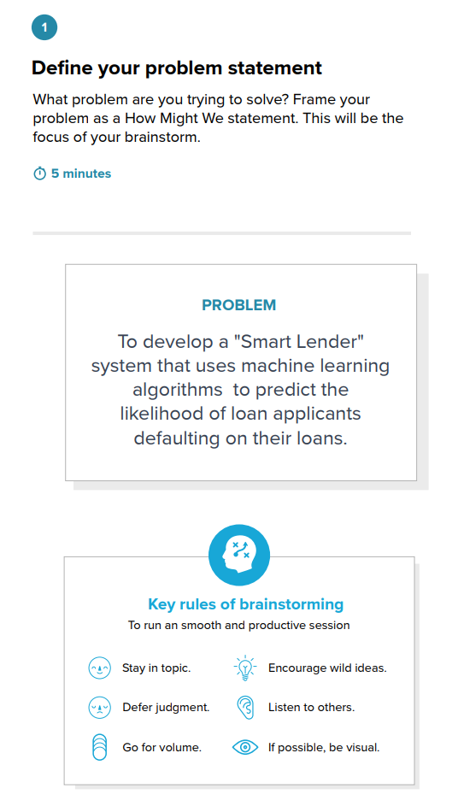

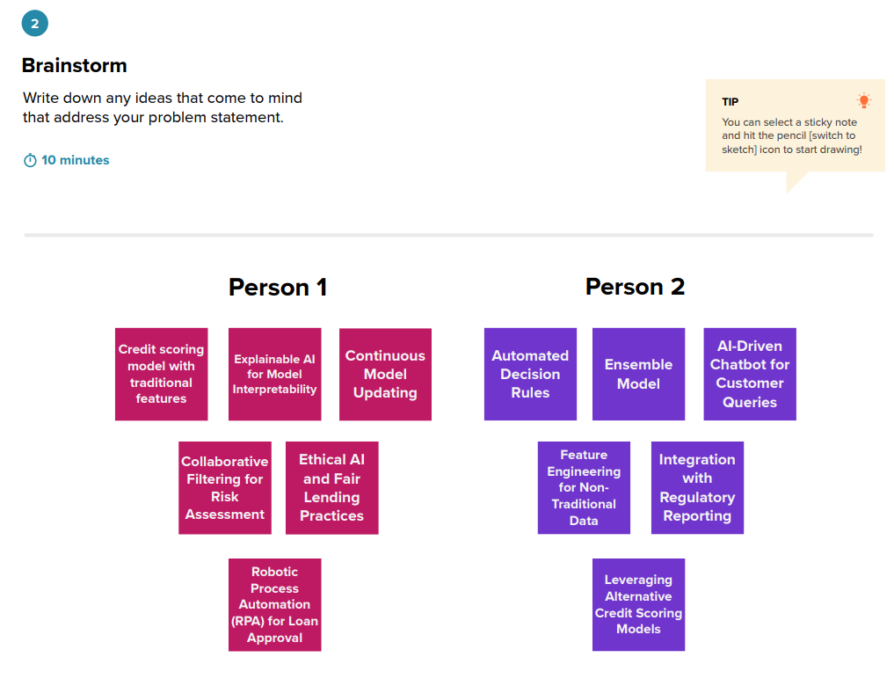

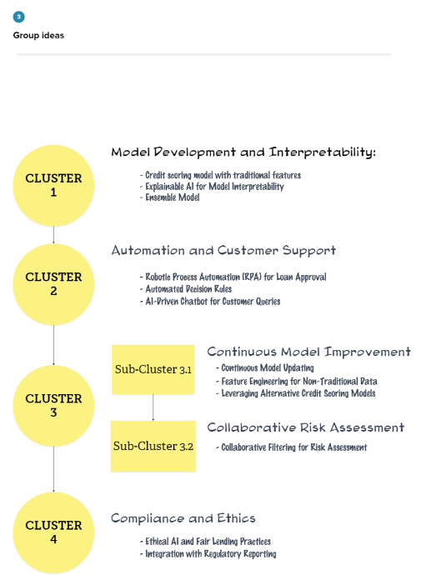

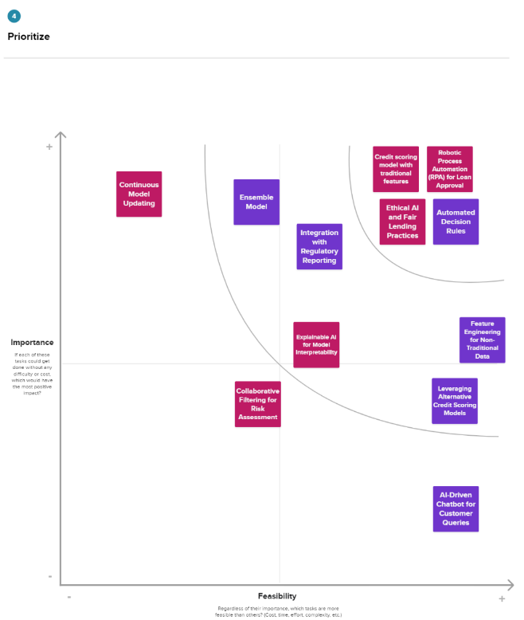

Check Plagiarism

1. **REQUIREMENT ANALYSIS:**
   1. **FUNCTIONAL REQUIREMENT:**

* Data Preprocessing:

Description: The system shall facilitate comprehensive data preprocessing, including cleaning, handling missing values, and addressing outliers, to ensure the quality and integrity of the dataset.

Rationale: Quality data is fundamental to the effectiveness of machine learning models in credit risk evaluation.

* Algorithm Selection and Implementation:

Description: The system shall employ a selection of classification algorithms, namely Decision Trees, Random Forest, K-Nearest Neighbors (KNN), and XGBoost, ensuring their effective implementation for training and testing.

Rationale: Utilizing diverse algorithms allows for a robust evaluation, enhancing the model's ability to generalize to various data patterns.

* Model Training and Evaluation:

Description: The system shall undertake rigorous model training and evaluation, utilizing appropriate metrics such as accuracy, precision, recall, and F1-score to assess the performance of each algorithm.

Rationale: Thorough evaluation is critical for identifying the most accurate and reliable model for loan approval prediction.

* Model Storage:

Description: The system shall save the selected model in a pickle (.pkl) format, ensuring efficient storage and retrieval for future use.

Rationale: Storing the model in a portable format enables seamless integration into other applications and frameworks.

* Flask Integration:

Description: The system shall integrate with the Flask web framework to provide a user-friendly interface for interacting with the credit risk evaluation model.

Rationale: Flask integration ensures accessibility and usability, allowing stakeholders to interact with the model in real-time.

* IBM Deployment:

Description: The system shall facilitate deployment on the IBM Cloud platform to ensure scalability, reliability, and accessibility.

Rationale: Leveraging cloud infrastructure enhances the system's scalability and availability, accommodating varying workloads and ensuring consistent performance.

* Continuous Monitoring and Updating:

Description: The system shall implement mechanisms for continuous monitoring of model performance and allow for periodic updates to adapt to changing economic conditions.

Rationale: Regular monitoring and updates are crucial for maintaining the model's relevance and effectiveness over time.

* Ethical Considerations Integration:

Description: The system shall incorporate features to address ethical considerations, ensuring fairness and transparency in credit risk evaluation.

Rationale: Ethical considerations are paramount in financial applications to prevent biases and maintain trust among users and stakeholders.

* 1. **NON – FUNCTIONAL REQUIREMENTS:**
* Performance:

Description: The system shall demonstrate low-latency response times, providing real-time predictions for credit risk evaluation.

Rationale: Timely decision-making is crucial in the financial sector; therefore, the system's performance should meet or exceed industry standards.

* Scalability:

Description: The system shall be designed to handle an increasing volume of users and data, ensuring scalability to accommodate growing demands.

Rationale: As user and data loads fluctuate, the system should scale seamlessly to maintain optimal performance without degradation.

* Reliability:

Description: The system shall exhibit high reliability, with minimal downtime and robust error handling mechanisms.

Rationale: Reliability is paramount in financial applications to prevent disruptions and ensure continuous service availability.

* Security:

Description: The system shall implement industry-standard security measures to protect sensitive financial data, ensuring confidentiality and integrity.

Rationale: Security is of utmost importance in financial applications to safeguard against unauthorized access and data breaches.

* Usability:

Description: The user interface shall be intuitive and user-friendly, requiring minimal training for users to interact effectively with the system.

Rationale: Enhancing usability ensures that stakeholders, including bank personnel and end-users, can easily navigate and utilize the system.

* Compliance:

Description: The system shall adhere to relevant data protection regulations, ethical guidelines, and industry standards governing financial applications.

Rationale: Compliance ensures that the system operates within legal and ethical boundaries, fostering trust among users and regulatory bodies.

* Interoperability:

Description: The system shall be designed to seamlessly integrate with existing banking systems and data sources.

Rationale: Interoperability ensures a smooth transition and coexistence with the bank's current infrastructure, minimizing disruptions during implementation.

* Maintainability:

Description: The system shall be designed with modular and well-documented code to facilitate ease of maintenance and updates.

Rationale: Maintainability is essential for adapting to future technological changes, addressing issues promptly, and incorporating necessary updates.

* Adaptability:

Description: The system shall be adaptable to changes in regulatory requirements, ensuring that it remains compliant with evolving financial regulations.

Rationale: The financial sector is subject to regulatory changes, and the system must adapt to new requirements without compromising its functionality.

* Auditability:

Description: The system shall maintain comprehensive logs of user interactions, model predictions, and system activities for auditing and traceability purposes.

Rationale: Auditability is essential for transparency and accountability, allowing for the tracking of actions and decisions made within the system.

1. **PROJECT DESIGN:**
   1. **DATA FLOW DIAGRAM:**

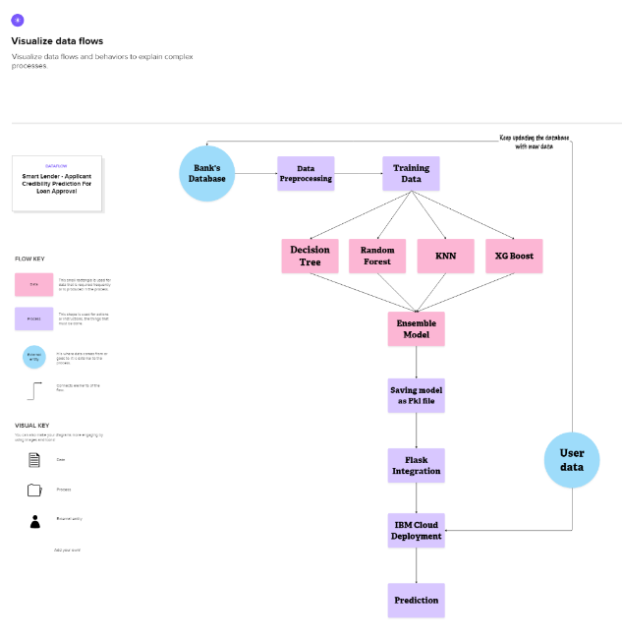

* 1. **SOLUTION ARCHITECTURE:**

1. **PROJECT PLANNING AND SCHEDULING:**
   1. **TECHNICAL ARCHITECTURE:**
   2. **SPRINT PLANNING AND ESTIMATION:**
   3. **SPRINT DELIVERY SCHEDULE:**
2. **CODING AND SOLUTIONING:**
   1. **FEATURE 1: UNDER-SAMPLING TO ADDRESS CLASS IMBALANCE**

In order to handle the class imbalance present in the dataset, I implemented under-sampling using the RandomUnderSampler from the imblearn library. This technique ensures that the minority class is adequately represented in the training data, preventing the model from being biased towards the majority class.  
  
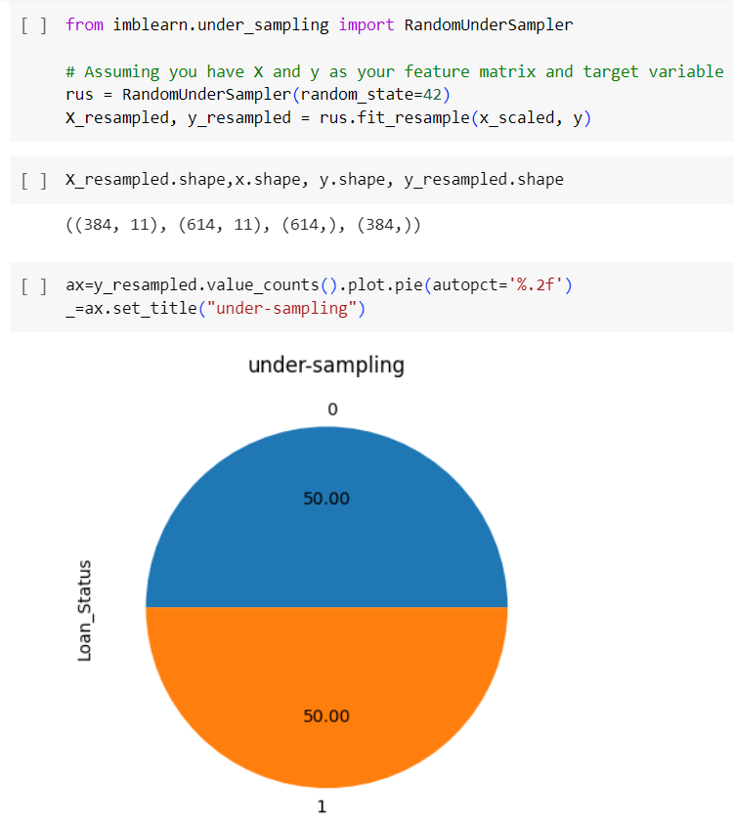

* 1. **HYPERPARAMETER TUNING AND VALIDATION FOR MULTIPLE MODELS**

To optimize the performance of the machine learning models, hyperparameter tuning and validation were conducted for each individual model. Grid Search Cross Validation was employed to systematically explore hyperparameter combinations, ensuring the models are fine-tuned for optimal results. Cross-validation scores were utilized to evaluate the models' performance on different subsets of the training data, providing a more robust assessment.

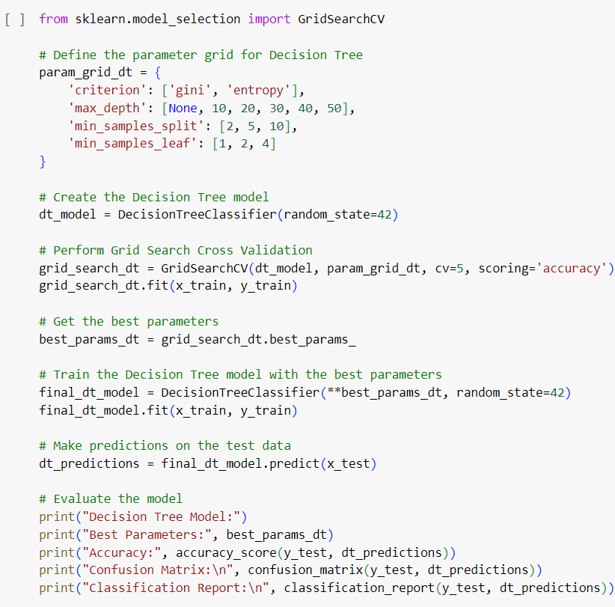

1. **PERFORMANCE TESTING:**
   1. **PERFORMANCE METRICS:**

* ACCURACY:

Accuracy is a fundamental metric that measures the overall correctness of the model. It is the ratio of correctly predicted instances to the total instances.

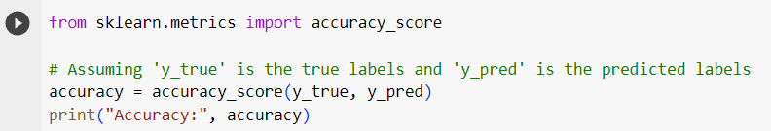

* CONFUSION MATRIX:

A confusion matrix provides a detailed breakdown of the model's performance, showing the number of True Positives (TP), True Negatives (TN), False Positives (FP), and False Negatives (FN).

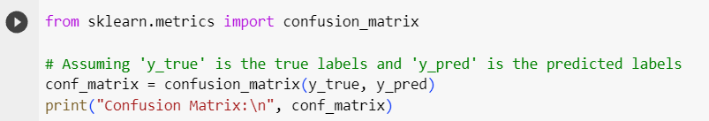

* PRECISION

Precision is the ratio of correctly predicted positive observations to the total predicted positives. It is a measure of the accuracy of the positive predictions.

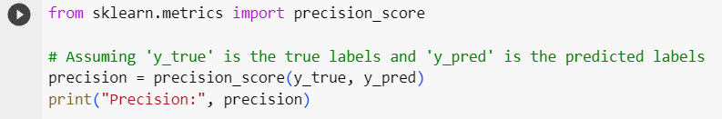

* RECALL

Recall, also known as sensitivity or True Positive Rate, measures the ratio of correctly predicted positive observations to the total actual positives. It assesses the model's ability to capture all relevant instances.

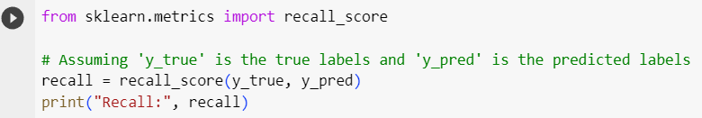

* F1 – SCORE

The F1 score is the harmonic mean of precision and recall. It provides a balance between precision and recall and is particularly useful when there is an imbalance between classes.

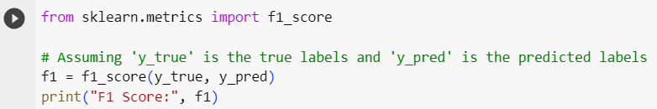

* ROC

ROC-AUC is a performance metric for binary classification problems. It represents the area under the ROC curve, which plots the true positive rate against the false positive rate.

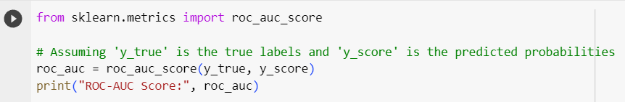

1. **RESULTS:**
   1. **OUTPUT SCREENSHOTS:**

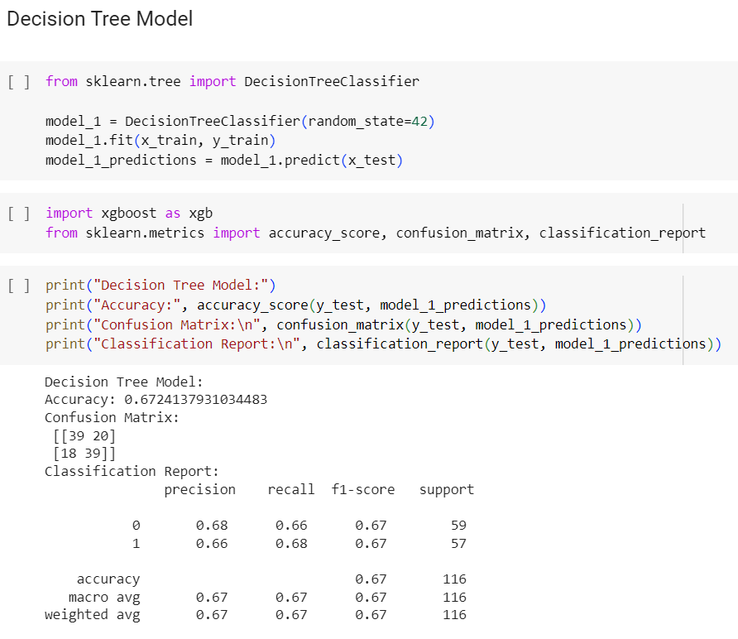

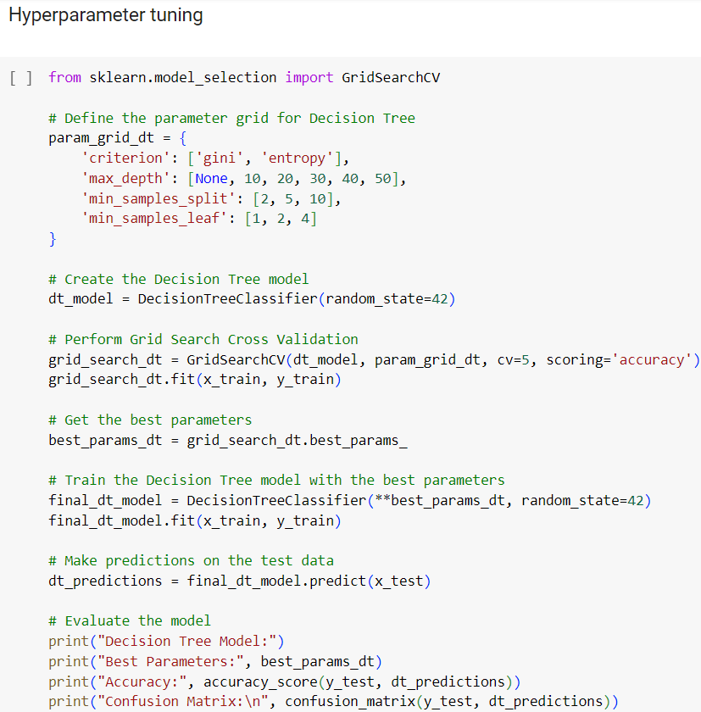

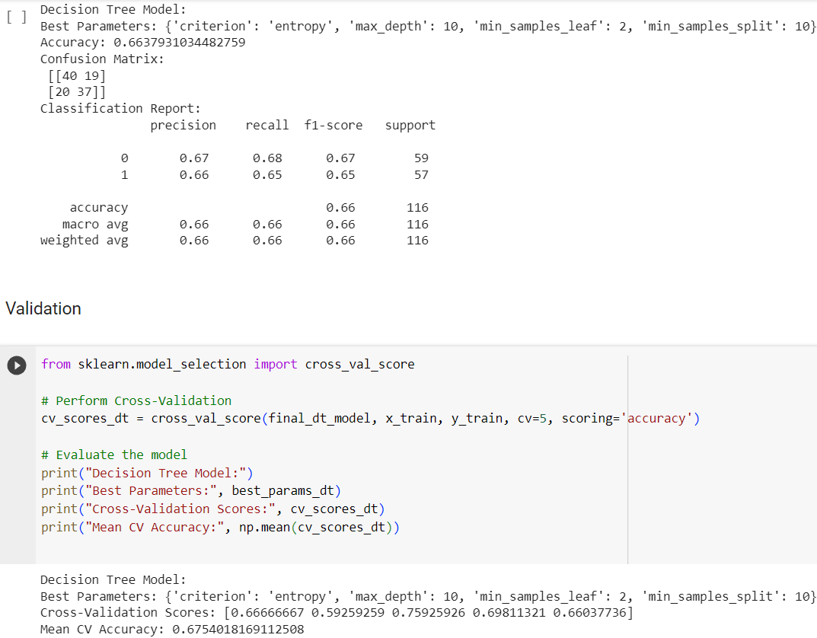

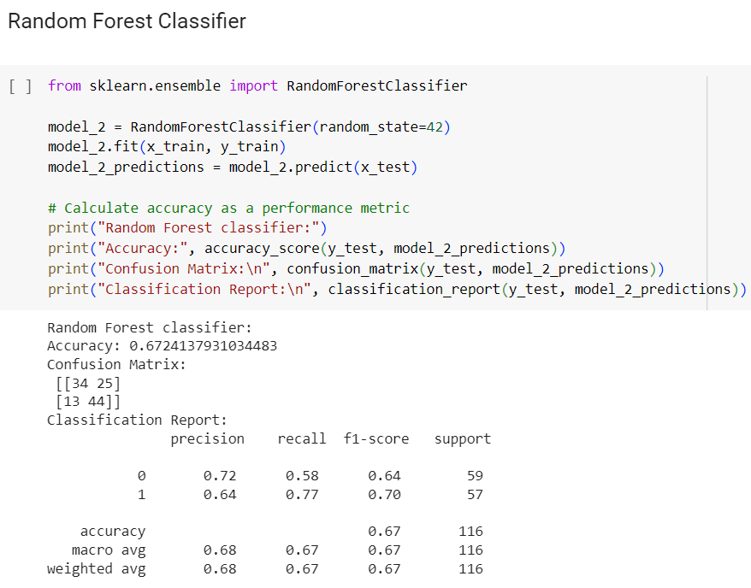

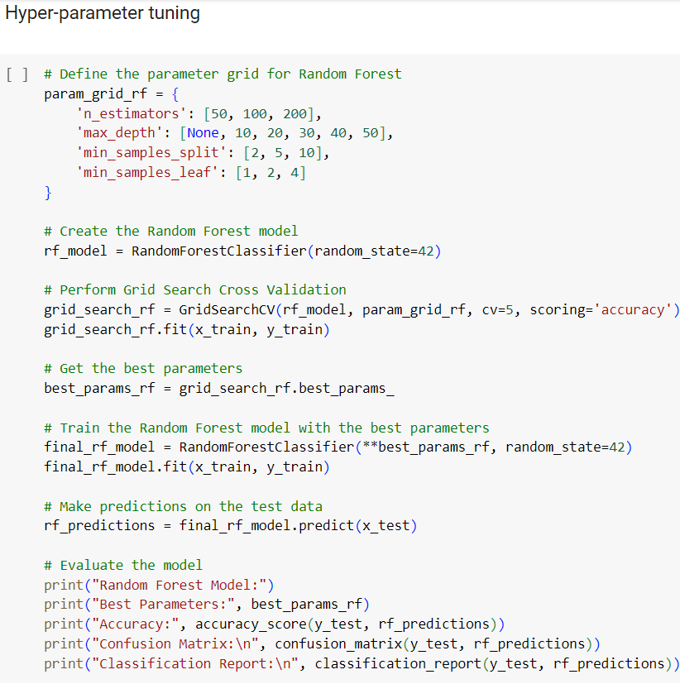

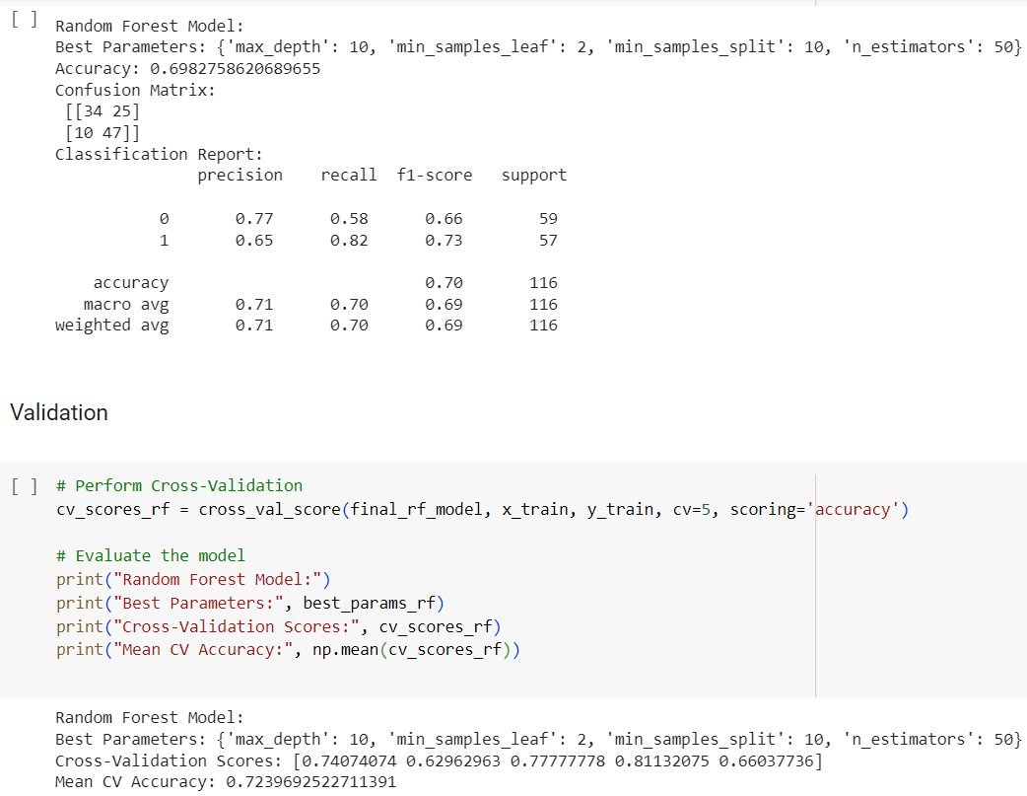

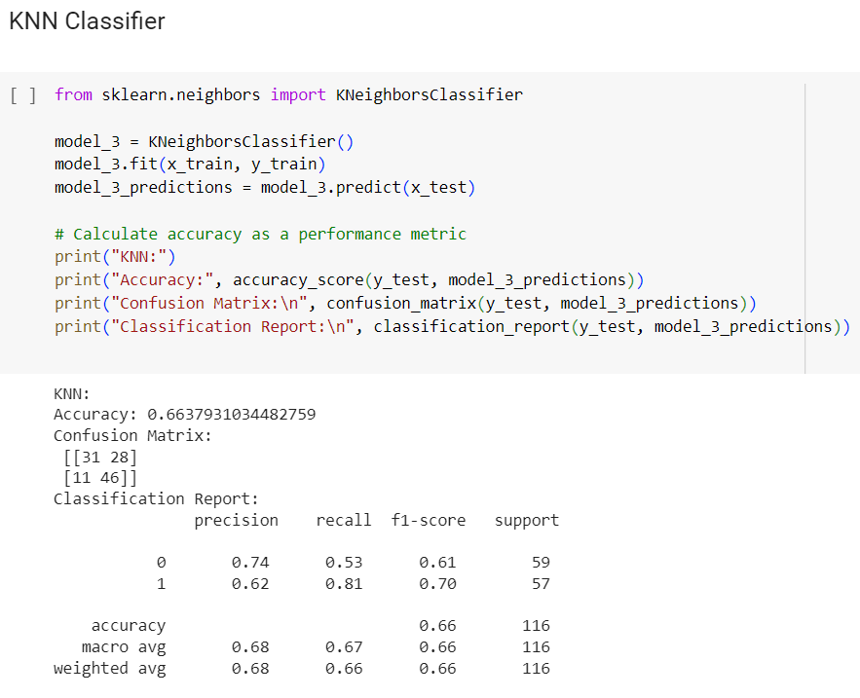

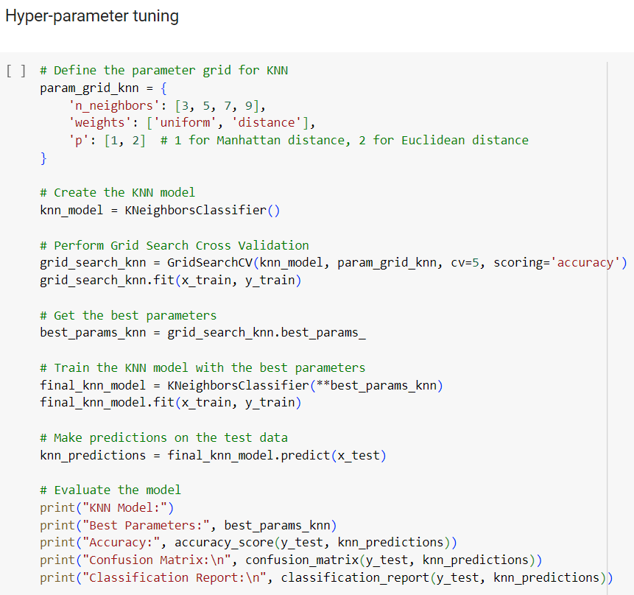

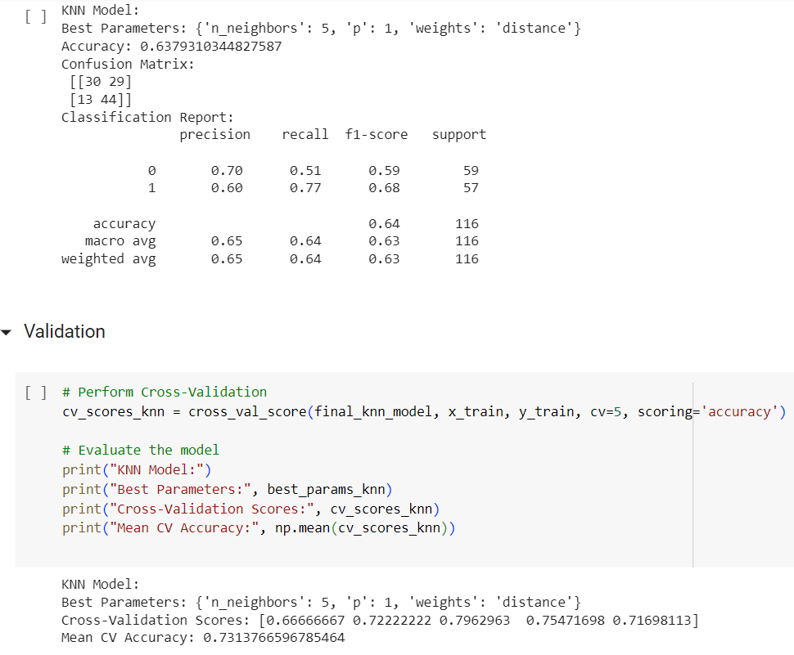

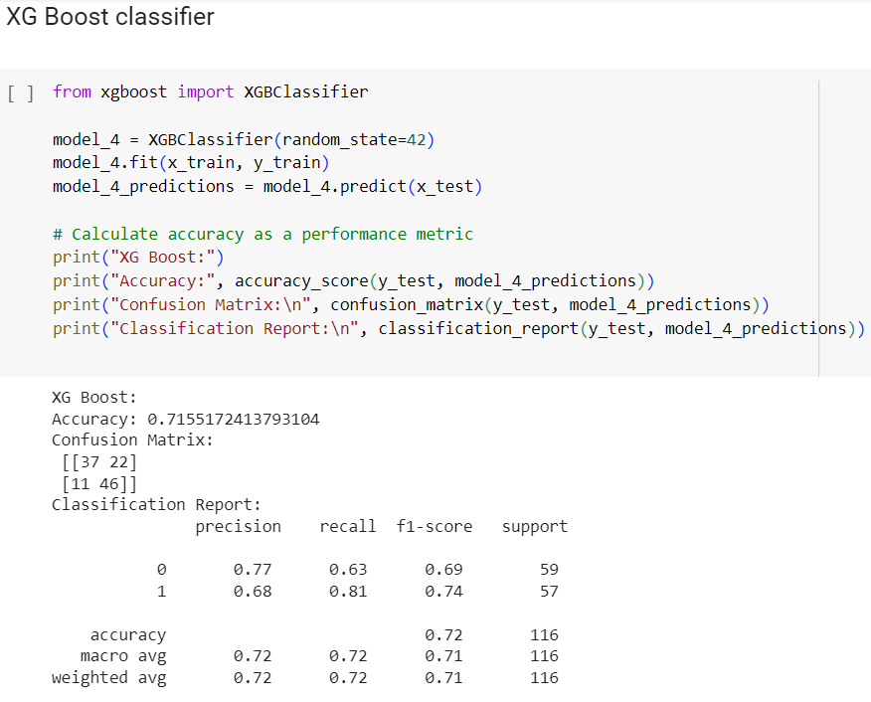

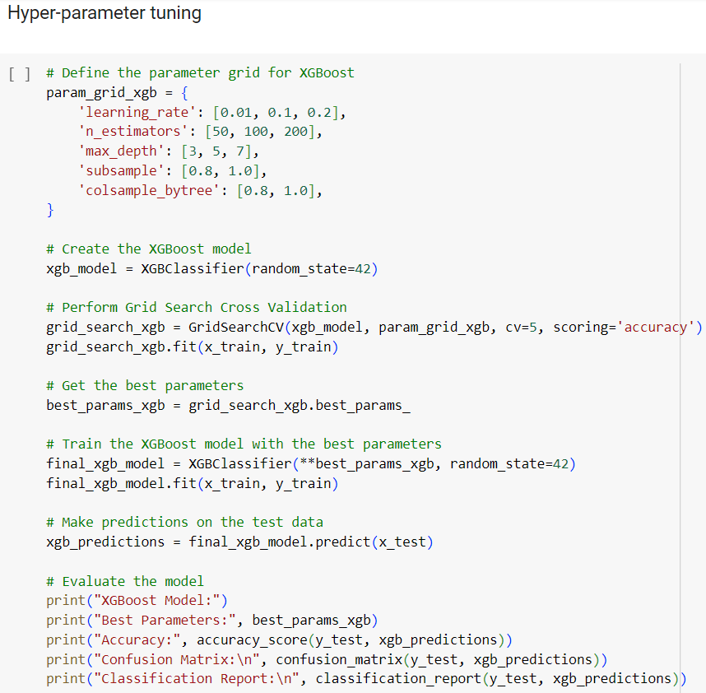

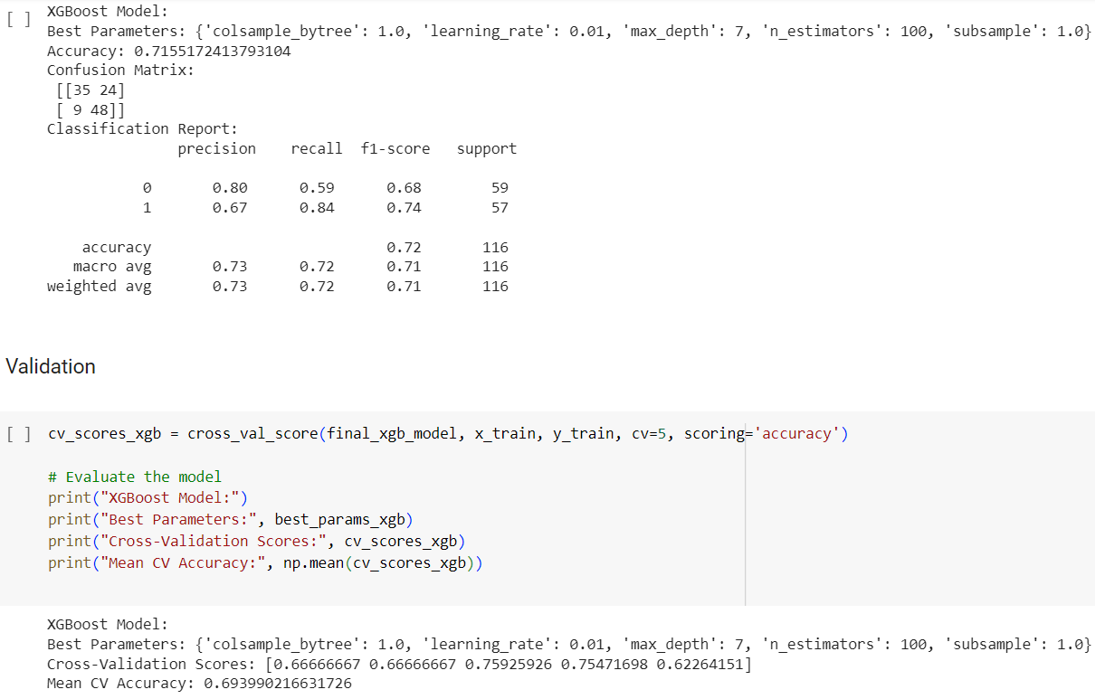

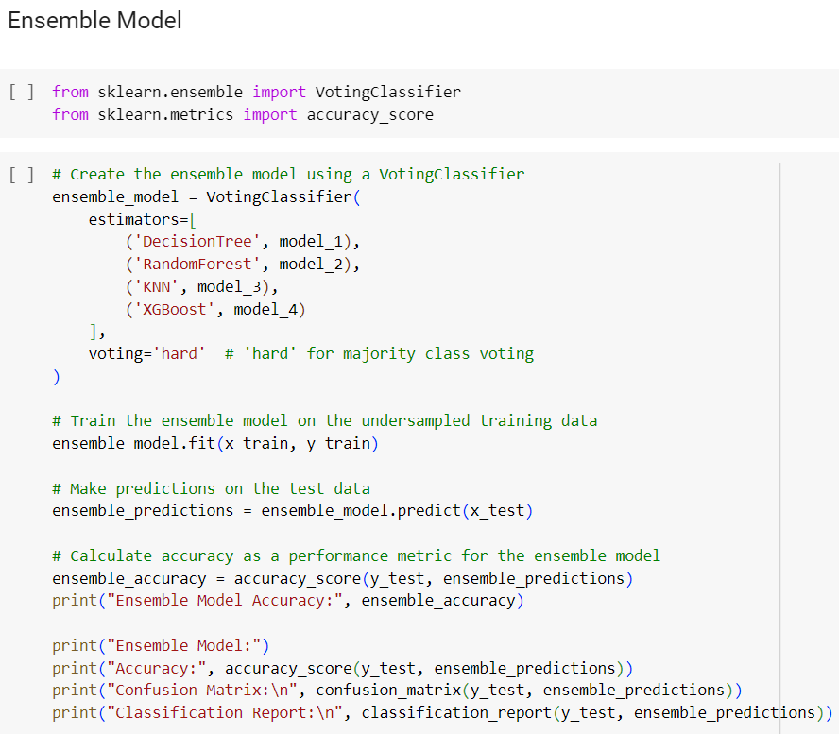

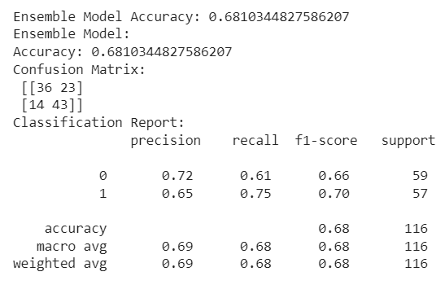

**10.ADVANTAGES AND DISADVANTAGES**

**Advantages:**

Enhanced Predictive Accuracy:

Advantage: The implementation of advanced machine learning algorithms, including Decision Trees, Random Forest, KNN, and XGBoost, enhances the predictive accuracy of credit risk evaluation, leading to more informed loan approval decisions.

Risk Mitigation and Loss Reduction:

Advantage: Proactively identifying potential loan defaulters facilitates risk mitigation, minimizing financial losses for the financial institution by preventing exposure to non-profitable assets.

Improved Decision-Making:

Advantage: The integration of machine learning models contributes to more informed and data-driven decision-making in the loan approval process, ensuring a more thorough and objective evaluation.

Scalability and Accessibility:

Advantage: Integration with the Flask web framework and deployment on the IBM Cloud platform enhances the system's scalability and accessibility, allowing for seamless interactions and widespread usage.

Ethical Considerations:

Advantage: The incorporation of features addressing ethical considerations promotes fair and transparent credit risk evaluation, reducing the potential for biases and fostering trust among users and stakeholders.

**Disadvantages:**

Data Quality Challenges:

Disadvantage: Inherent challenges in data quality, such as incomplete or inaccurate data, may compromise the effectiveness of machine learning models, leading to biased predictions.

Interpretability Issues:

Disadvantage: Some advanced machine learning algorithms, particularly ensemble methods, may lack interpretability, making it challenging for stakeholders to fully understand and trust the factors influencing loan approval predictions.

Imbalanced Datasets:

Disadvantage: Imbalances in the dataset, with a disproportionate number of approved and rejected loans, may lead to biased model training, affecting its ability to accurately predict defaulters, especially in minority class instances.

Dynamic Economic Factors:

Disadvantage: The models may struggle to adapt to dynamic economic conditions, impacting their predictive accuracy over time. Failure to account for economic fluctuations may result in outdated models.

Deployment and Integration Complexities:

Disadvantage: Integrating machine learning models into existing banking systems, ensuring scalability, and deploying them in real-time environments can present logistical challenges, potentially causing delays in implementation.

Security and Privacy Concerns:

Disadvantage: The use of sensitive financial data in the credit risk evaluation process raises security and privacy concerns. Ensuring robust security measures is crucial to safeguard against unauthorized access and data breaches.

Maintenance Challenges:

Disadvantage: Maintaining machine learning models, especially in a rapidly evolving technological landscape, may pose challenges. Regular updates and adaptations are essential to address issues and incorporate improvements.

**11. CONCLUSION:**

Advant In summary, the Smart Lender initiative represents an important step towards changing the credit risk assessment process in the banking industry. This project uses advanced machine learning, including decision trees, random forest, KNN, and XGBoost to improve accuracy and decision-making regarding loan approval.  
  
The advantages of smart lending are clear: It can detect illegal sources of credit, thus reducing risk and reducing the financial burden of financial institutions. Participating in fair decision-making ensures fairness and transparency and addresses issues related to bias in credit risk assessment.  
  
However, the project also acknowledged some challenges, such as insufficient data, translation issues and the nature of the work. These challenges highlight the need for continuous monitoring, updating, and adherence to ethical standards to maintain long-term effectiveness.  
  
As we grapple with the complexities of data-driven decision-making in finance, the Smart Lending Project has positioned itself as a positive change. By addressing limitations and leveraging its strengths, the system not only improves the loan approval process but also helps increase the security and Trust of financial institutions.  
  
As we move forward it will be important to continue working on standardisation, resolving issues that arise and keeping up with ethical considerations. The Smart Lender project is a testament to the intersection of technology and finance, working to support a new era of accuracy and transparency in credit risk assessment.

**11.FUTURE SCOPE:**

The future of the Smart Lender program goes beyond the initial implementation, offering opportunities for continued development and expansion. Further research and development could focus on optimizing the operating model to address translation issues and enable stakeholders to gain a deeper understanding of credit outcomes. Additionally, exploring advanced skills to address data disparities and develop a model to adapt to the dynamic market will help increase profitability.  
  
Integrating new technologies such as artificial intelligence and learning into government can increase transparency and expand the capabilities of machines. Collaboration with regulators and industry stakeholders can facilitate the integration of changing compliance standards and create a seamless operating environment through changes. Additionally, regular customer feedback and usability studies can provide additional links to ensure a positive and user-friendly experience.  
  
The future of smart lenders lies in their ability to adapt to the dynamic financial environment, embrace technological advances, and embrace data science and wisdom practices. As the project grows, it has the potential to become a solution for financial institutions seeking a robust, transparent and flexible way to assess credit risk around the world and respond to changes in business and finance.

1. **APPENDIX:**

SOURCE CODE: <https://colab.research.google.com/drive/16ZP7d4lfQ8fIkPcv_aNTf99fToCBDPCQ?usp=sharing>

GITHUB AND PROJECT DEMO:

<https://github.com/smartinternz02/SI-GuidedProject-601019-1697640456>

Check Plagiarism